CONTACT: Nancy Richards – 917-873-6389 (cell) /nancy@northcoastrep.org
MEDIA PAGE: www.northcoastrep.org/press

FOR IMMEDIATE RELEASE, PLEASE:

ALWAYS…PATSY CLINE, RETURNS TO NORTH COAST REP
TOUCHING, TUNEFUL MUSICAL DRAMA
Created and originally directed By Ted Swindley
Performances Beginning Wednesday, December 8, 2021
Running Through Sunday, January 2, 2022
Directed by Allegra Libonati

Solana Beach, CA – In a departure from the usual holiday fare, North Coast Repertory Theatre proudly presents ALWAYS…PATSY CLINE, a dramatic musical experience certain to thrill fans of the iconic singer. Based on the touching story of Patsy’s friendship with Louise Seger, a fan who continued a correspondence with her to the end of her life, this song-filled valentine has garnered enormous success throughout the United States. Enjoy a host of enduring Cline hits including “Crazy,” “I Fall to Pieces,” and “Walking After Midnight.” Because of the limited run, it’s wise to order tickets early.

Allegra Libonati directs Katie Karel* and Becky Barta*. The design team includes Marty Burnett (Scenic Design), Matthew Novotny (Lighting Design), Elisa Benzoni (Costumes), Joseph Butler (Sound mixer) Peter Herman (Hair & Wigs). Daniel Doss (Music Director & Keyboard), Scott Harvester (Bass), Tim Cook (Pedal Steel Guitar), Tom Versen (Drums) and Aaron Rumley* is the Stage Manager & Sound.

*The actor or stage manager appears through the courtesy of Actors’ Equity Association, the union of professional actors and stage managers in the United States. For background information and photos, go to www.northcoastrep.org/press.

ALWAYS…PATSY CLINE begins Wednesday, December 8, 7:30 pm. It will play Wednesday through Saturday at 7:30 pm, with matinees on Saturday and Sunday at 2 pm and a Thursday matinee on December 23rd & 30th at 2pm, through January 2, 2022. Tickets are $49 each. Season subscribers - $39 each. Seniors, Students, Military & Educators - $3 off admission. Call 858-481-1055, or visit www.northcoastrep.org to purchase tickets.

FACT SHEET:

WHAT: NORTH COAST REPERTORY THEATRE presents
ALWAYS…PATSY CLINE
Created and Originally directed by Ted Swindley
Directed by Allegra Libonati

CAST: Katie Karel,* Becky Barta*

WHERE: North Coast Repertory Theatre
987 Lomas Santa Fe Drive, Ste. D
Solana Beach, CA 92075

SCHEDULE: Opens: December 8, 2021
Closes: Closes January 2, 2022
Wed. – Sat. Nights at 7:30 pm, Sat. & Sun @ 2PM,
Thursday matinee on December 23 & 30 at 2pm

PRICES: All Performances $49.00

DISCOUNTS: Seniors, Students, Military & Educators $3.00 off admission. Season Subscribers, $10.00 off each ticket.

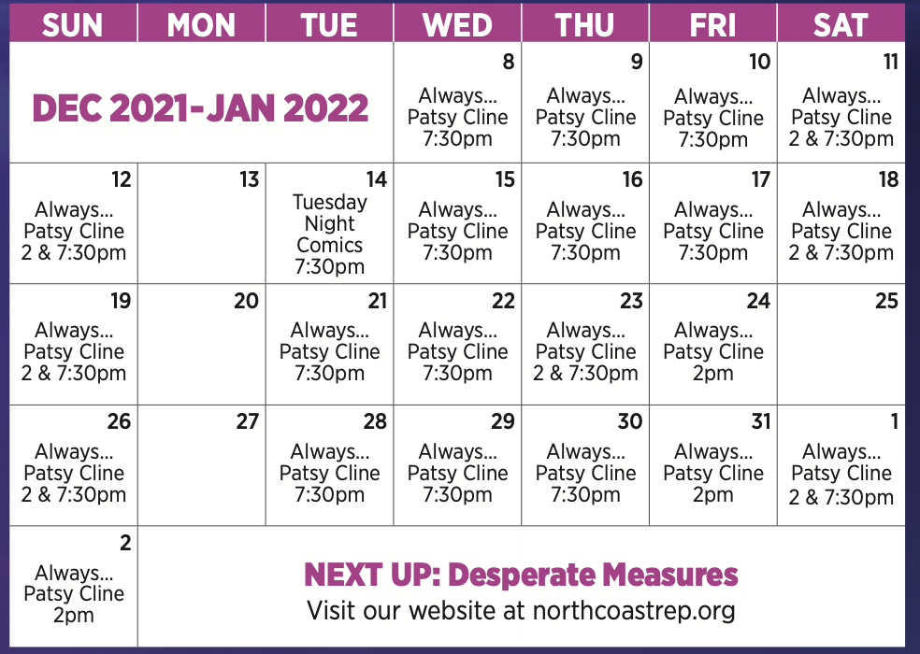

BIOS:

TED SWINDLEY (Creator/Original Director) is internationally known as writer and director of the popular musical, Always...Patsy Cline. He is the founding artistic director Of Stages Rep in Houston, Texas. He was also named to the Esquire Magazine's register of outstanding Americans in arts and letters. Mr. Swindley was the receipient of the Los Angeles Dramalogue award for outstanding direction of Carnal Knowledge by Jules Feiffer. Currently, he is president of Ted Swindley Productions, Inc., a theatrical licensing and consulting company, and continues his 30 year career writing plays and musicals, consulting and mentoring playwrights, as well as directing plays for various theatres throughout the U.S. and abroad. Mr. Swindley is an active member of The Dramatists Guild Of America And Stage Directors And Choreographers.
ALLEGRA LIBONATI (Director) is delighted to be back at North Coast Rep with this joyous company. Allegra is a director for theatre, circus, opera and new events. Broadway: Tony Award-winning revival of HAIR (Assistant). Off-Broadway: In the Body of the World by Eve Ensler (Associate) Regional: Resident Director and Artistic Associate at the American Repertory Theatre for 9 seasons directing and developing productions including Sleep No More, Pippin, The Tempest, Crossing, Prometheus Bound, The Donkey Show, The Pirate Princess, The Light Princess, The Snow Queen. Opera: Stravinsky’s The Rake’s Progress at Boston Lyric Opera and Verdi’s Falstaff at Opera Omaha. Shakespeare: Julius Caesar for The Old Globe, San Diego, Romeo & Juliet for Commonwealth Shakespeare Company on the Boston Common, King Lear for Wayne State University, Detroit. She has directed award winning outdoor musicals and Shakespeare productions for thirteen seasons at the Summer Theatre of New Canaan including: Legally Blonde, Hairspray, South Pacific, My Fair Lady, Carousel, 12th Night, Taming of the Shrew, A Midsummer Night’s Dream, Henry IV, Part 1&2. Internationally she directed a new immersive adventure show, Peter Pan’s Neverland in Beijing, China. Allegra guest teaches at Harvard University, UNLV, Westfield U, Wayne State U, and is a MIT Director’s Fellow. She is a member of Tut’Zanni Commedia Company and a graduate of NYU and CMU. Currently she lives in Las Vegas with her husband, Brett Alters (a North Coast rep alum!) and new baby Everly, her favorite production to date!

KATIE KAREL* (Patsy) is grateful to be back at North Coast with her favorite gal Patsy, and her favorite pal Cathy (Louise). Off Broadway: New Victory Theatre (Lucky Duck). Regional: North Coast Repertory Theatre (Last of the Red Hot Lovers, Sherlock Holmes and...The Great Nome Gold Rush), Okoboji Summer Theatre (Always…Patsy Cline), Max and Louie Productions (Indecent), Unicorn Theatre (Chesapeake, Heathers, Women Playing Hamlet, Vera Stark, Bloody Bloody Andrew Jackson), Kansas City Actors Theatre (Skylight), KC Rep (Last Days Of Summer, Into The Woods), Starlight Theatre (Hairspray, Flat Stanley), New Theatre (Hairspray, Addams Family, You Can’t Take It With You, Always…Patsy Cline), Musical Theatre Heritage (Evita, Sunday In The Park With George, Sweeney Todd, 1776), Egads Productions ( Rocky Horror, Valhalla, In Trousers, Evil Dead). Her love and thanks to David, Allegra, the band, crew, and creative team. For Gary - her biggest fan. Thank YOU for supporting the arts. www.katiekarel.com

BECKY BARTA* (Louise) is thrilled to be making her North Coast Rep debut! This rendering marks Becky's 31st production of this beautiful play, directing and/or performing both roles in theaters across the country from New York (Off-Broadway) to up the road in Brea, California and winning a few awards along the way. Becky had the great pleasure of befriending the real Louise Seger Zurbuchen. Other New York credits include the Broadway and National Tour productions of Les Miserables (Mme Thenardier), Off-Broadway's Frankenstein (cast recording), Meet Me In St. Louis, Forbidden Broadway, Sessions and the new play, Stiff. She spent several seasons as Mrs. Claus in the Christmas Spectacular at Radio City Music Hall. Becky's CD, Crazy And Then Some (available in the lobby) celebrates this genre of music and was recorded with her husband, musician and director, David Sonneborn. Love and thanks to Mom, David S., David E., and YOU for supporting live theater!
AARON RUMLEY* (Stage Manager/Sound Designer) has worked on over 120 shows at North Coast Rep, over 50 as a stage manager, over 20 as a designer.
MUSICIANS
DANIEL DOSS (Music Director / Piano / Conductor) is thrilled to be reunited with North Coast Rep for this special return engagement. This is Daniel’s fourth production of Always… Patsy Cline. Since 2002, Daniel has established himself as a Music Director, Conductor, Composer and Collaborative Pianist in over 85 musical theatre productions across the globe, including the National Tours of The Color Purple, The Addams Family and Ragtime. Thanks for supporting live theatre and enjoy the show! danieldoss.com

SCOTT HARVESTER (Bass) is new to North Coast Repertory Theater. As an electric and upright bass player, he has experience playing a variety of musical styles but especially enjoys opportunities to play American roots music. When he is not sitting in on a production, he can be found playing bluegrass, country, and gospel music locally.
TIM “STEELBONE” COOK (Pedal Steel Guitar) A trombone soloist since childhood, Tim has been paying his honky-tonk dues on Pedal Steel Guitar since the 70s, performing with TV stars to football players, from Lawrence Welk’s Champagne Lady to Country Dick’s Beat Farmers/Hayseeds, becoming a fixture on the local scene in the 80s and 90s, carrying on a San Diego roots tradition. His musical contributions can be found on many national and local recordings. You might catch him performing locally with his “Bones” band or other artists on Pedal Steel/Trombone/Button Accordion, and sometimes even Bass.
TOM VERSEN (Drums / Percussion) he thrilled to be a part of this beautiful production.(NCRT) Back to Bacharach and David, Jacques Brel, I Love you Because, Spelling Bee, Dames at Sea. (San Diego Rep) Respect, John Doe the Musical, Bessie’s Blues, Menopause the Musical,(Cygnet) Rock of Ages, Music Man, Rocky Horror Picture Show, Animal Crackers, (LPT) Music Man, Boomers, The Secret Garden, The Mysteries of Edwin Drood, Pete N’ Keely. CCHS Modern Millie, Godspell (Off Broadway) – Suds. Thanks to all of you for supporting the arts and doing what you can to keep everyone healthy.

CREATIVE STAFF
MARTY BURNETT (Set Design) Resident Designer at North Coast Rep since 1992 and has designed more than 200 productions for the theater. Other design venues include Sahara and Hacienda hotels in Las Vegas, Claridge Hotel, Atlantic City and Drury Lane Chicago.
MATTHEW NOVOTNY (Light Design) is pleased to be designing another show for North Coast Rep, where he has designed close to forty shows over the past seven years. Matthew is currently the Lighting Designer in Residence for San Diego Musical Theatre as well as North Coast Rep, and his work can be seen at a wide variety of theatres across San Diego. Matthew holds a B.A. in Technical Theatre from San Diego State and a master’s degree in Lighting Design from Boston University. Matthew is married to his beautiful wife Amanda, with 5 AMAZING children: Ragan, Harper, Heston, Maddex and Harrison .
ELISA BENZONI+ (Costume Design) is thrilled to be working on her fourth season at
North Coast Rep including numerous Craig Noel nominated productions. Elisa has also worked on over a hundred productions across Southern California with theatres such as The Old Globe, La Jolla Playhouse, Geffen Playhouse, South Coast Repertory Theatre, Laguna Playhouse, San Diego Repertory Theatre, Diversionary Theatre and New Village Arts. Being Italian born, Elisa has also had the opportunity to work and perfect her craft in Europe. Elisa holds a costume design M.F.A. from UCSD where she currently is an adjunct professor. www.elisabenzoni.com
JOSEPH BUTLER (Sound Mixer) is an audio engineer and musician, born and raised in San Diego, CA. Recent credits include: I Love You You’re Perfect Now Change, Miss You Like Hell, Little Women, Wizard of Oz (Patio Playhouse), and Hunchback of Norte Dame (Living Light Theater). BA of Science in Audio Engineering from Arts Institute of California, San Diego.

PHILLIP KORTH (COVID-19 Compliance Officer/Props) is an actor, writer, craftsman, and educator. He earned BA in Acting and Creative Writing from Western Michigan University and his MFA in Acting from the University of Connecticut. He is a Veteran of the United States Marine Corps and served two tours of duty in Iraq. In addition to designing and managing props for NCRT, Phillip is also the Education Associate at The Theatre School @ North Coast Rep.
PETER HERMAN (Hair & Wig Design) has previously designed wigs for over 30 North Coast Rep productions. Peter teaches wig and makeup design at San Diego State University. He is glad to be part of the creative team on this show.
About the North Coast Repertory Theatre:
North Coast Repertory Theatre, under the artistic leadership of David Ellenstein since 2003, is a professional Equity theatre founded in 1982 by Olive and Tom Blakistone. Currently celebrating its 40th season, North Coast Rep has received critical acclaim from media and audiences alike, and has evolved into one of the area’s leading performing arts organizations. North Coast Rep prides itself on employing the majority of its actors from Actors’ Equity Association for its high quality, award-winning productions, and staging works by established and emerging playwrights. Throughout its history, North Coast Rep has created a platform where artist and audience thrive through the intimacy of live theatre, recognizing the power of theatre to challenge complacency, revitalize the imagination, nurture the unexpected, and embrace the variety and diversity in our lives.
#####

